Title, maximum 2 lines (Times new roman, 14 pt, bold, centered)

Name Surname¹, Name Surname², Name surname corresponding autor³

¹ Department X, University Y, street address, Country.

² Department Z, University K, street address, Country.

³ Department H, University W, street address, Country.

email: corresponding.author@university.com

Abstract

Text of the abstract, maximum one page

Figures or tables can be added, provided that the abstract does not exceed the one-page limit.

Times new Roman, 11 pt, justified, single spacing

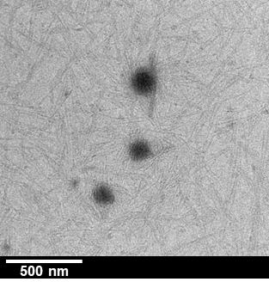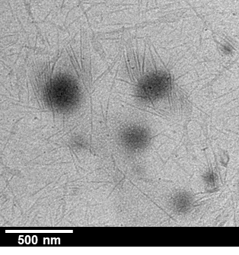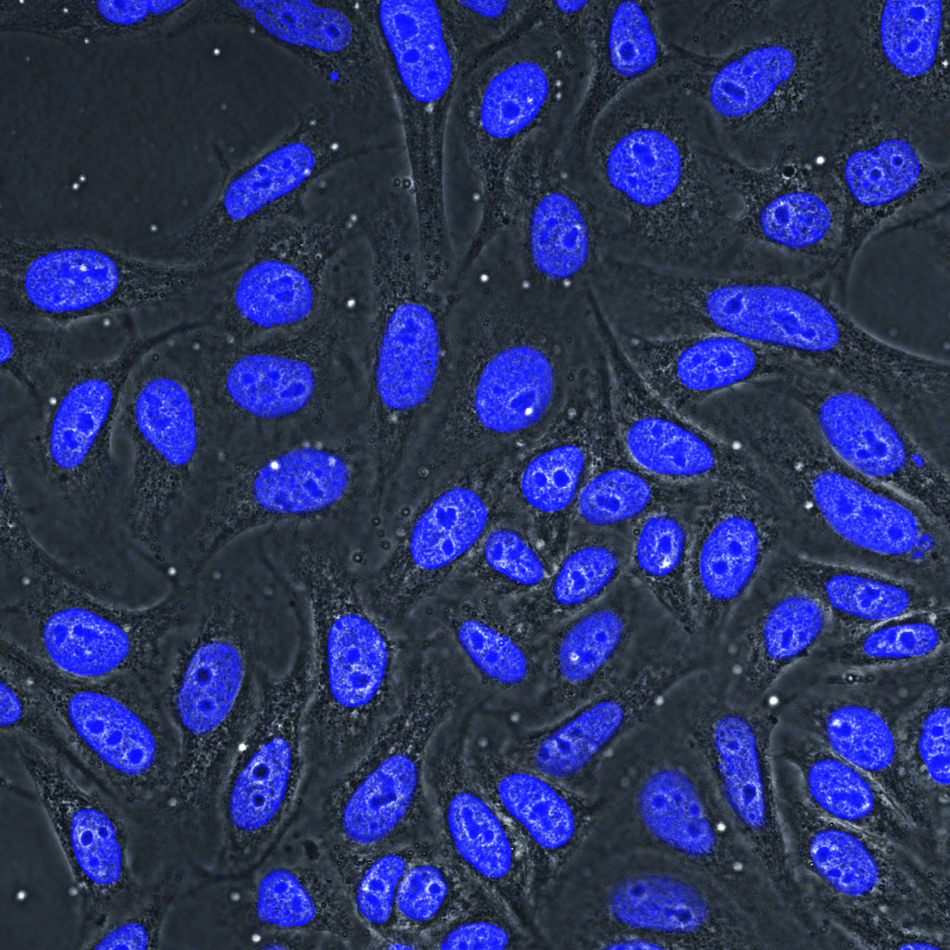

Figure 1. Caption of the figure Times new Roman, 11 pt, justified, single spacing

Acknowledgements
Acknowledgements of financial or intellectual contributions… Times new Roman, 11 pt, justified, single spacing

References

[1] A.B. Surname, C. Author and D. Coworker, Nat. Chem. 2018, 24, 1234.
…

